**LAB 5**

**Terraform Variables with Command Line Arguments**

**STEP 1: Create a new Directory.**



**STEP 2: Create terraform configuration file (main.tf)**

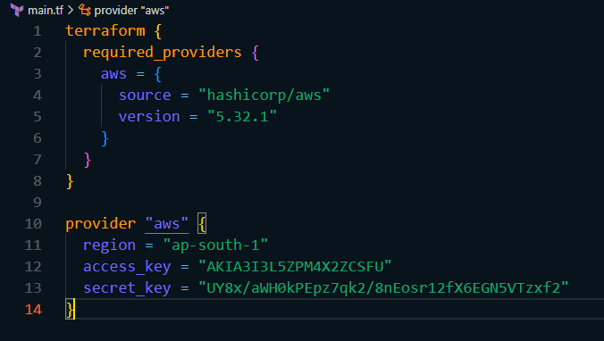

**STEP 3: Create a new file named variables.tf and define variables for region, ami, and instance_type.**

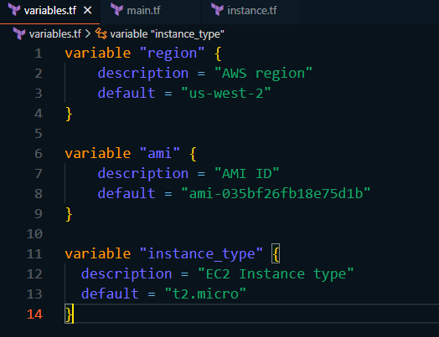

**STEP 4: Open a command line terminal and run terraform init.**

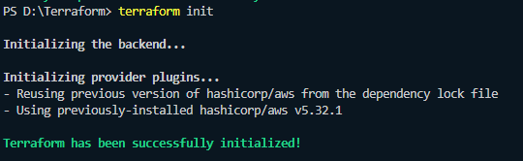

**STEP 5: Run the terraform apply command with command line arguments to set variable values dynamically**

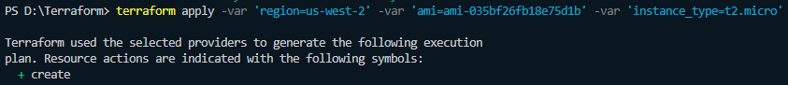

**STEP 6: Verify the creation of resources in AWS console.**



**STEP 7: Destroy/cleanup the resources.**

 